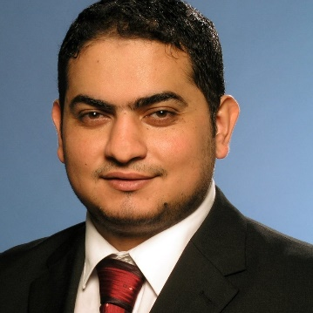
Biography
Dr. Ahmad Albalasie

Birzeit University
abalasie@birzeit.edu

Ahmad Albalasie is an Associate Professor in the Department of Mechanical and Mechatronics Engineering at Birzeit University, Palestine. He received his Ph.D. degree in Mechatronics Engineering from Technische Universität Berlin, Germany in 2016. He has a M.Sc. degree in Automatic Control Technologies from Politecnico di Torino, Italy in 2012. He gets his B.Eng. degree in Mechatronics Engineering from Palestine Polytechnic University (PPU), Palestine, in 2008. He worked as a lecturer for one year and he served for two years as a research and teaching assistant at PPU. His research is focused on the fields of Variable Stiffness Actuators, Robust Control, Optimal Control especially Model Predictive Control, Control of Haptics, and Control of Under-actuated Robots with several publications.

